Project Design Phase-II
Technology Stack
(Architecture & Stack)
Date | 25/9/2026
Team ID | SWTID-2026-8576
Project Name | AI WEATHER WISE
Maximum Marks | 4 Marks

1. Technical Architecture
Present the solution architecture as a clear diagram, together with the supporting information listed in Table 1 and Table 2. The diagram should show how the application components connect and where each technology is positioned.
AI WEATHER WISE - TECHNICAL ARCHITECTURE
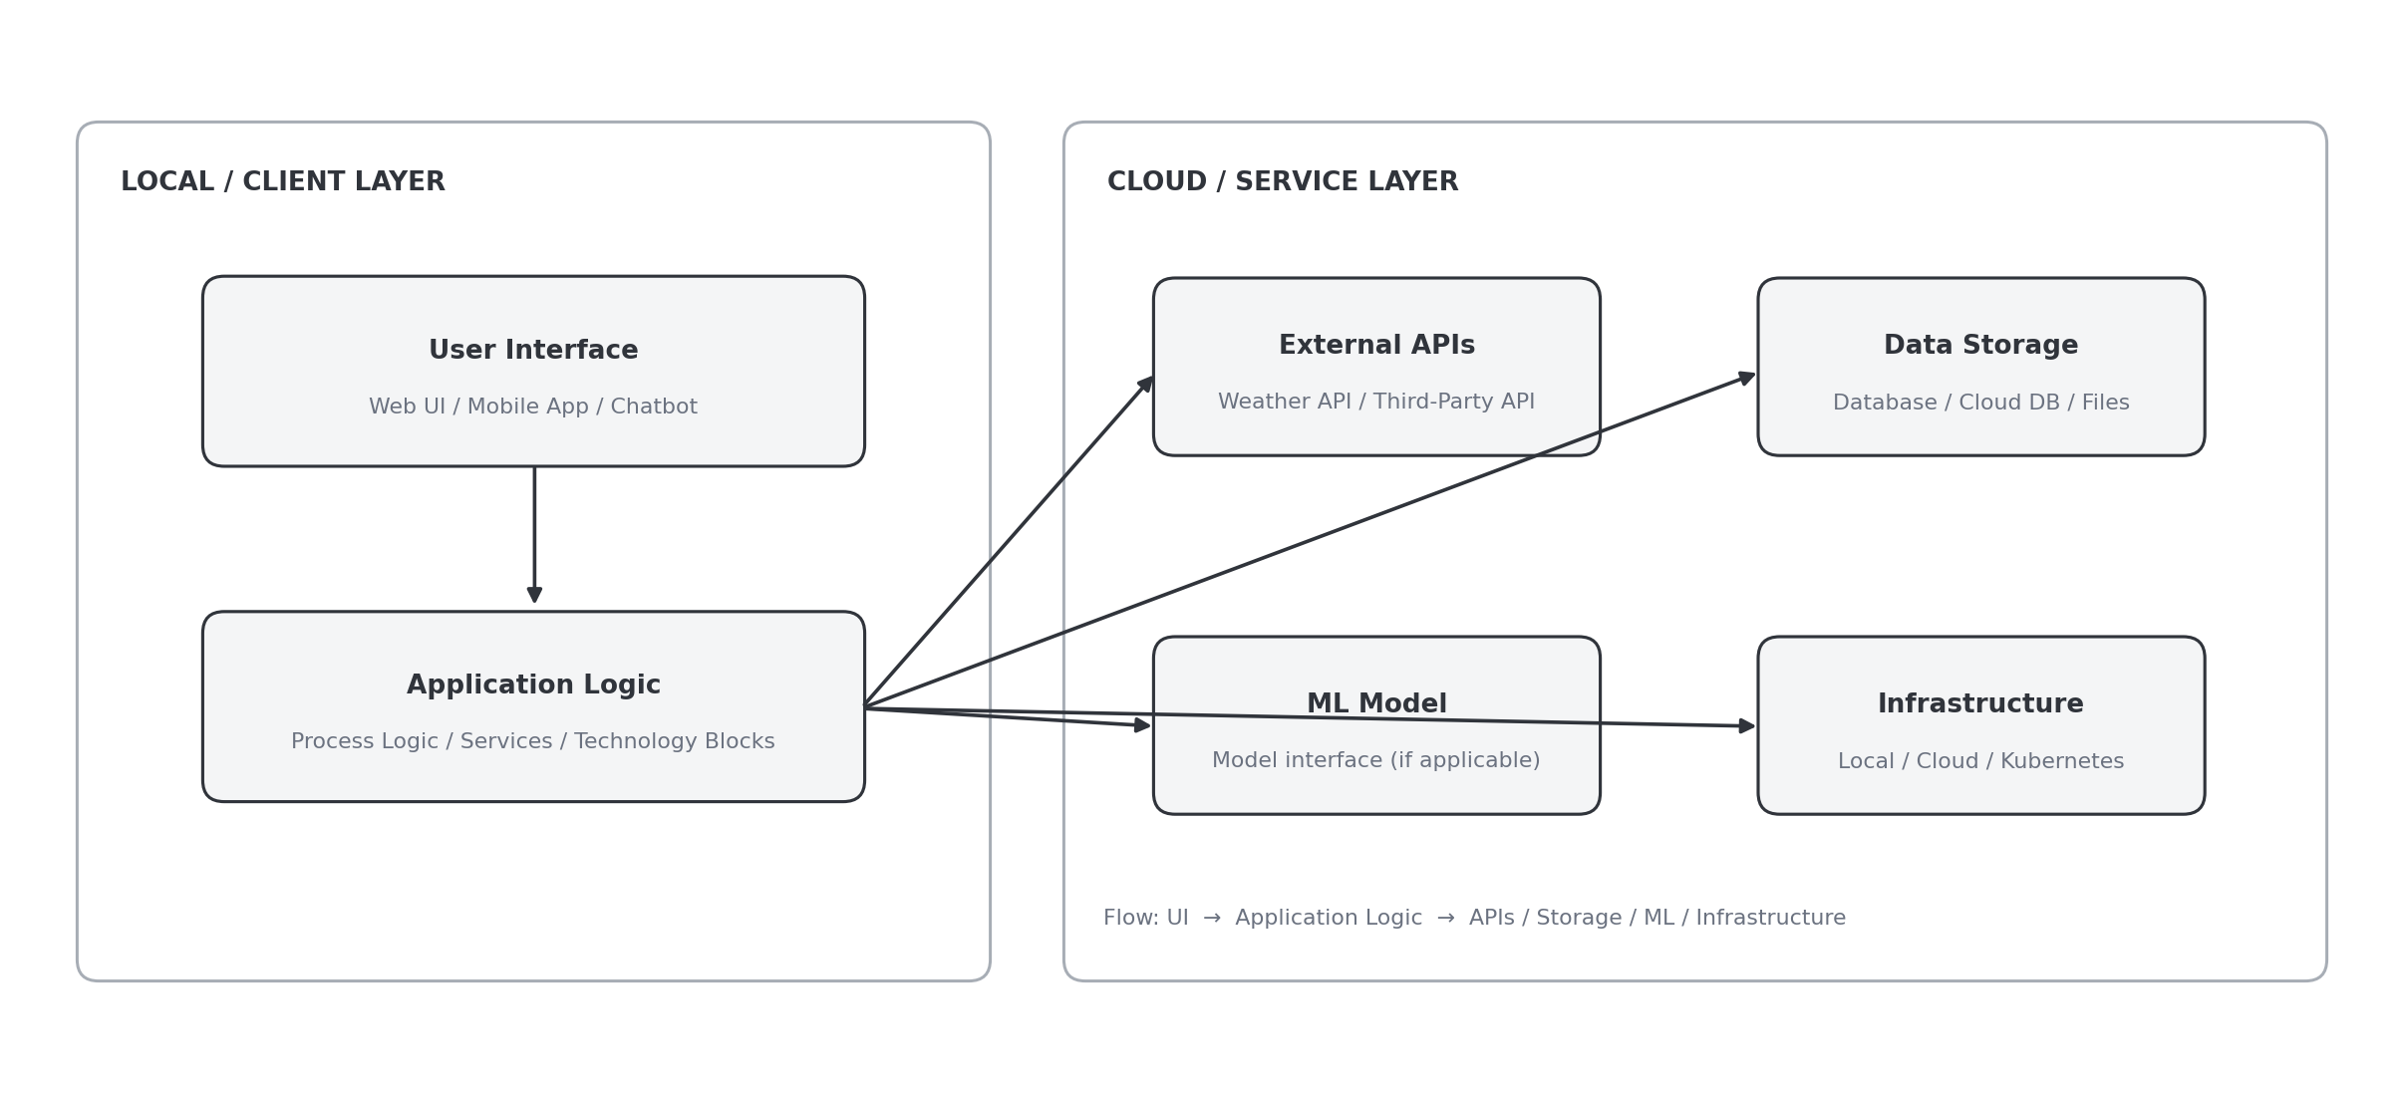
Guidelines
• Show every process as an application-logic or technology block.
• Clearly separate local infrastructure from cloud infrastructure.
• Display all external connections, including third-party APIs.
• Include the relevant data-storage components or services.
• Show the interface to machine-learning models wherever applicable.

2. Table 1 - Components & Technologies
S.No | Component | Description | Technology
1 | User Interface | Defines how users interact with the application, for example through a Web UI, mobile app, or chatbot. | HTML, CSS, JavaScript / Angular Js / React Js etc.
2 | Application Logic-1 | Represents the logic used to execute a process within the application. | Java / Python
3 | Application Logic-2 | Represents the logic or service used for another process in the application. | IBM Watson STT service
4 | Application Logic-3 | Represents the logic or service used for another process in the application. | IBM Watson Assistant
5 | Database | Specifies the required data types, database setup, and configuration details. | MySQL, NoSQL, etc.
6 | Cloud Database | Identifies the database service hosted in the cloud environment. | IBM DB2, IBM Cloudant etc.
7 | File Storage | Defines the storage needed for files used by the application. | IBM Block Storage or Other Storage Service or Local Filesystem
8 | External API-1 | States the purpose of the first external API integrated with the application. | IBM Weather API, etc.
9 | External API-2 | States the purpose of the second external API integrated with the application. | Aadhar API, etc.
10 | Machine Learning Model | Explains the role of the machine-learning model used by the solution. | Object Recognition Model, etc.
11 | Infrastructure (Server / Cloud) | Describes whether the application is deployed locally or in the cloud, including local and cloud server configuration. | Local, Cloud Foundry, Kubernetes, etc.

3. Table 2 - Application Characteristics
S.No | Characteristics | Description | Technology
1 | Open-Source Frameworks | List the open-source frameworks included in the application. | Technology of Opensource framework
2 | Security Implementations | List the implemented security and access-control measures, including firewall usage where relevant. | e.g. SHA-256, Encryptions, IAM Controls, OWASP etc.
3 | Scalable Architecture | Explain how the architecture supports scalability, such as through a 3-tier design or micro-services. | Technology used
4 | Availability | Explain how application availability is maintained, for example using load balancers or distributed servers. | Technology used
5 | Performance | Describe the performance design considerations, such as requests per second, caching, and CDN usage. | Technology used
Technology Stack Summary • AI WEATHER WISE

